# Difference between git merge and rebase

## Merging-: git merge is used to merge two development histories together.

1. First we make 2 commit in master.

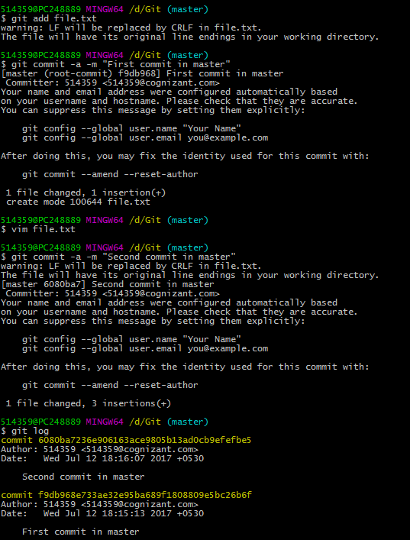

1. Switch to a new branch(newbranch), make 2 commit in newbranch.

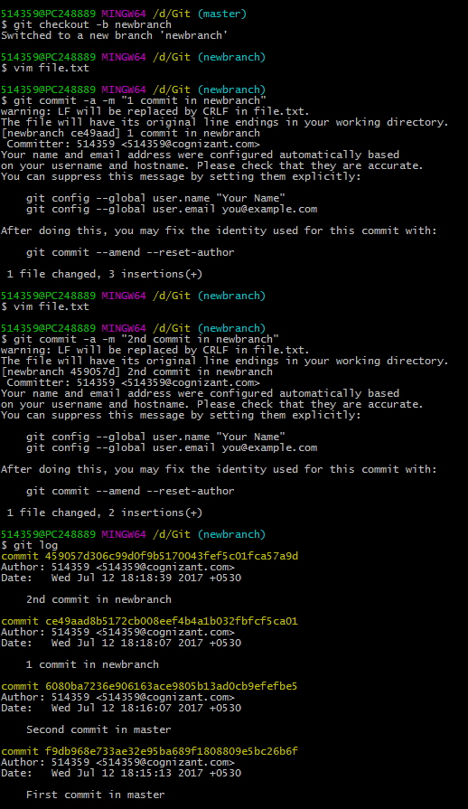

1. Now, suppose in master there are two more commits.

Hence total 4 commits in master and 2 commits on newbranch.

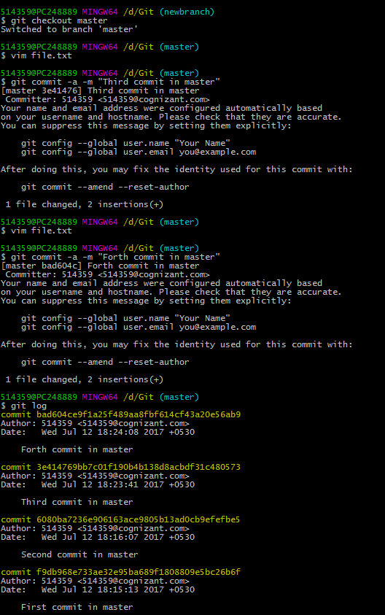

1. If we want to merge master with new branch, we will do git merge newbranch.

And after resolving the conflict in merging, we do a git commit for merge.

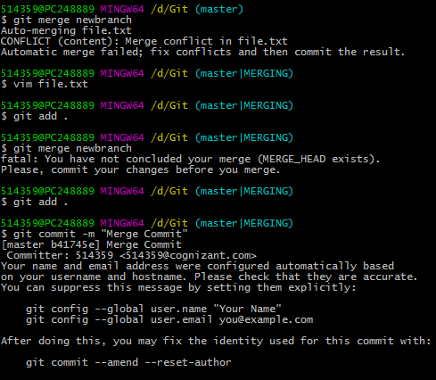

1. When we check the git log, we have 7 commits including the “Merge Commit”



## Rebasing-: Also use for merging two developments together, but Reapply commits on top of another base tip.

1. We will take the earlier case till step 3, where we have 4 commits on master and 2 on newbranch.
2. Here instead of git merge we use, git rebase.

In case of rebase, the base is first shifted to the latest commit in master, and also does not require any new commit to be done.

Hence, the git logs are much clear in the git rebase than in git merge.

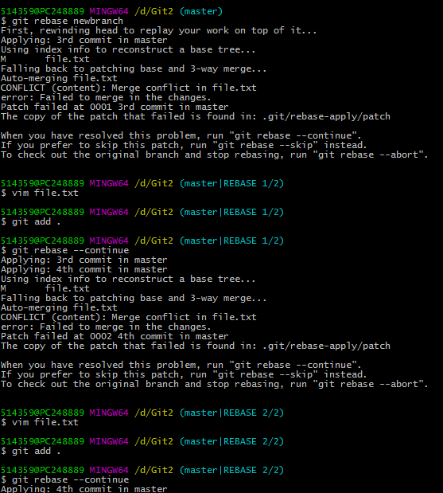

1. Checking git log shows, 6 commits instead of 7 commits in previous case.



## Cherry Picking-:

Git cherry-pick allows you to merge a single commit from one branch into another.

1. Switch to the branch where you want to apply the commit.
2. **Git cherry-pick commit-id** (Here commit id is the id of the commit in previous branch)
3. Hence cherry pick will create a new commit in another branch with same content.

